**source info:**

Mandatory step : SCL port needs to be open from veridate server to souce and target.

1) Login to the veridate server (psysvrddbk01)

2) check the agent base location i.e. /u01/veridata/agent/

3) Go to the agent base location and create the source directory name i.e server name (ex:ppdserslvkd1)

4) copy the files from existing directoty server to new directory server location these are the files.

VAOH.sh

drivers

config

agent.sh

configure_agent_ssl.sh

logs

agent.properties

5) Modified the agent.properties file to tns entry of the source server (ppdserslvkd1) and Port number (which is not usable)

6) start the agent by running the agent.sh script ( ./agent.sh start )

export JAVA_HOME=/usr/java/jdk1.8.0_121 – example **oracle@psysvrddbk01:/l->cat veridata_agent_ctl.sh**

7) we will find the logs in logs directory.

8) Similarly we have to setup for the target.

*********************

1. Go to the veridate server url

<http://psysvrddbk01.corp.intuit.net:8830/veridata/pages/config/connection/index.jsf>

1. Go to Configuration
2. Connection Configuration
3. New
4. **Connection Configuration:**

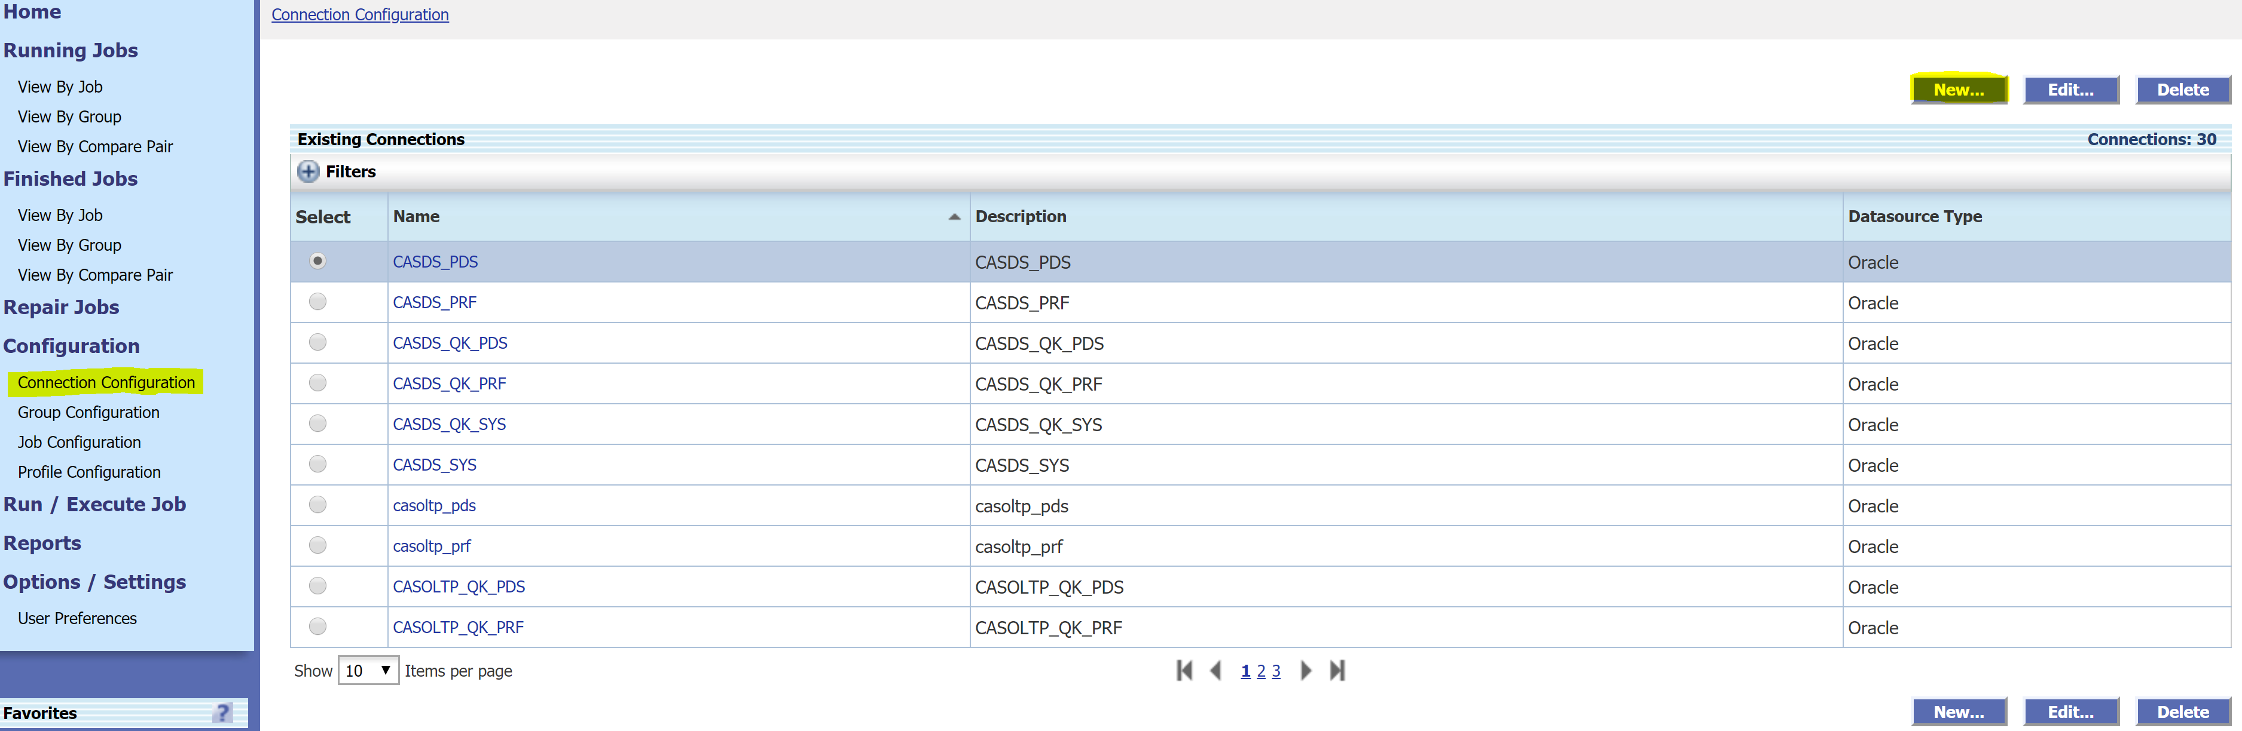

1. Provide the connection details.

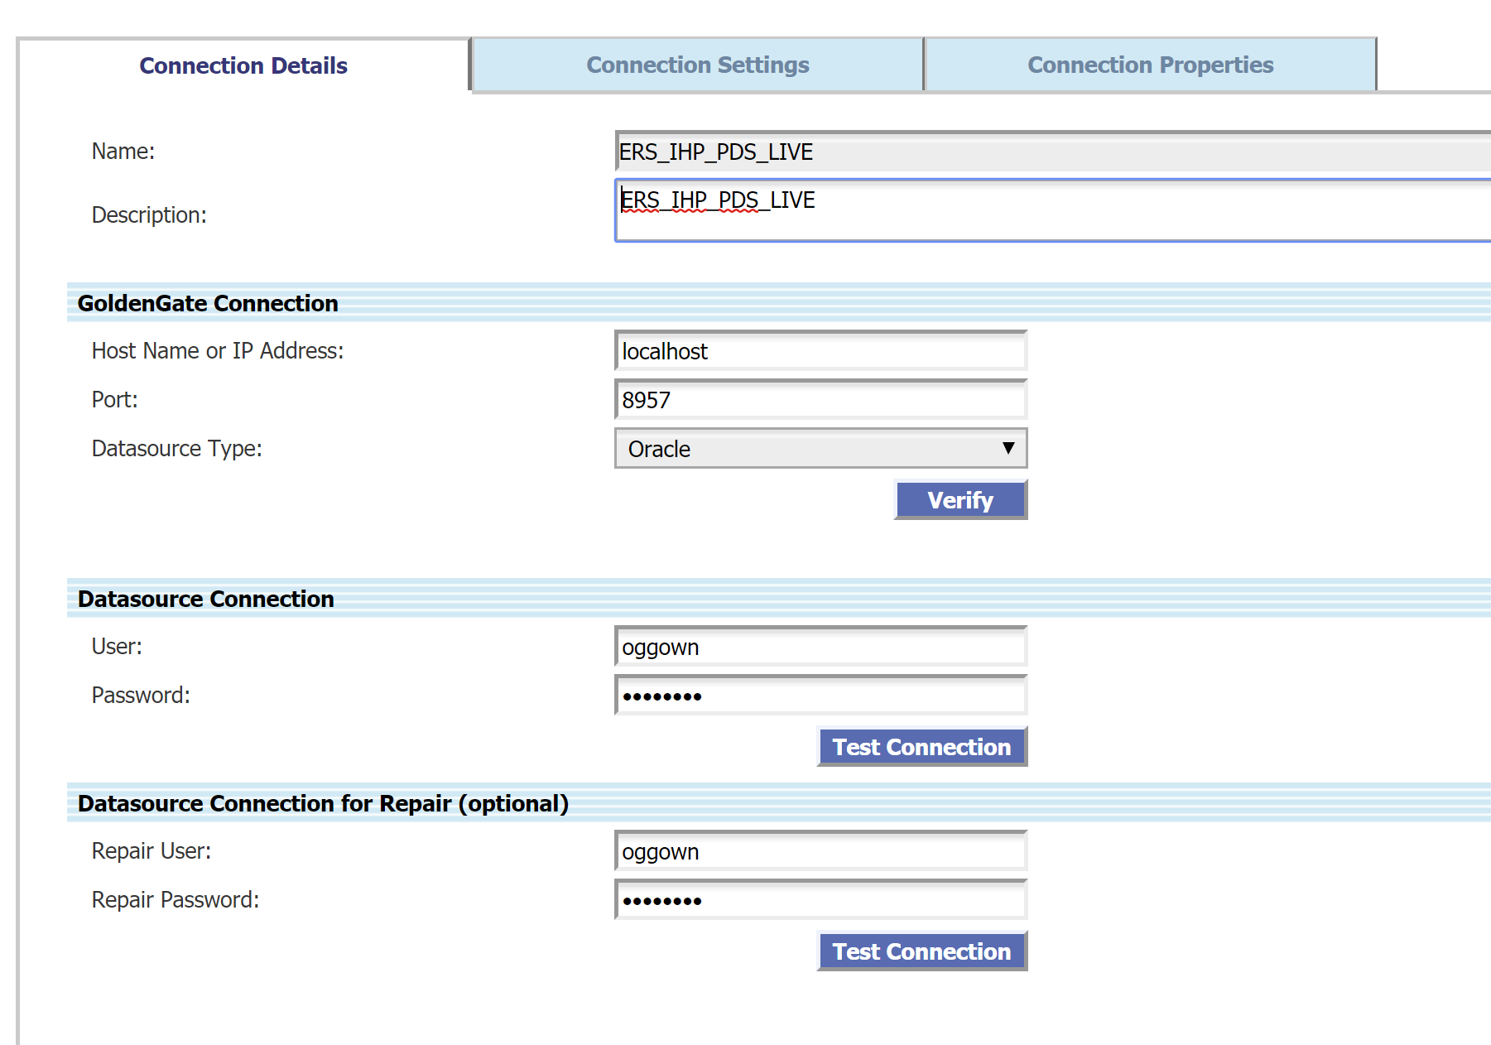

**2)Group Configuration:**

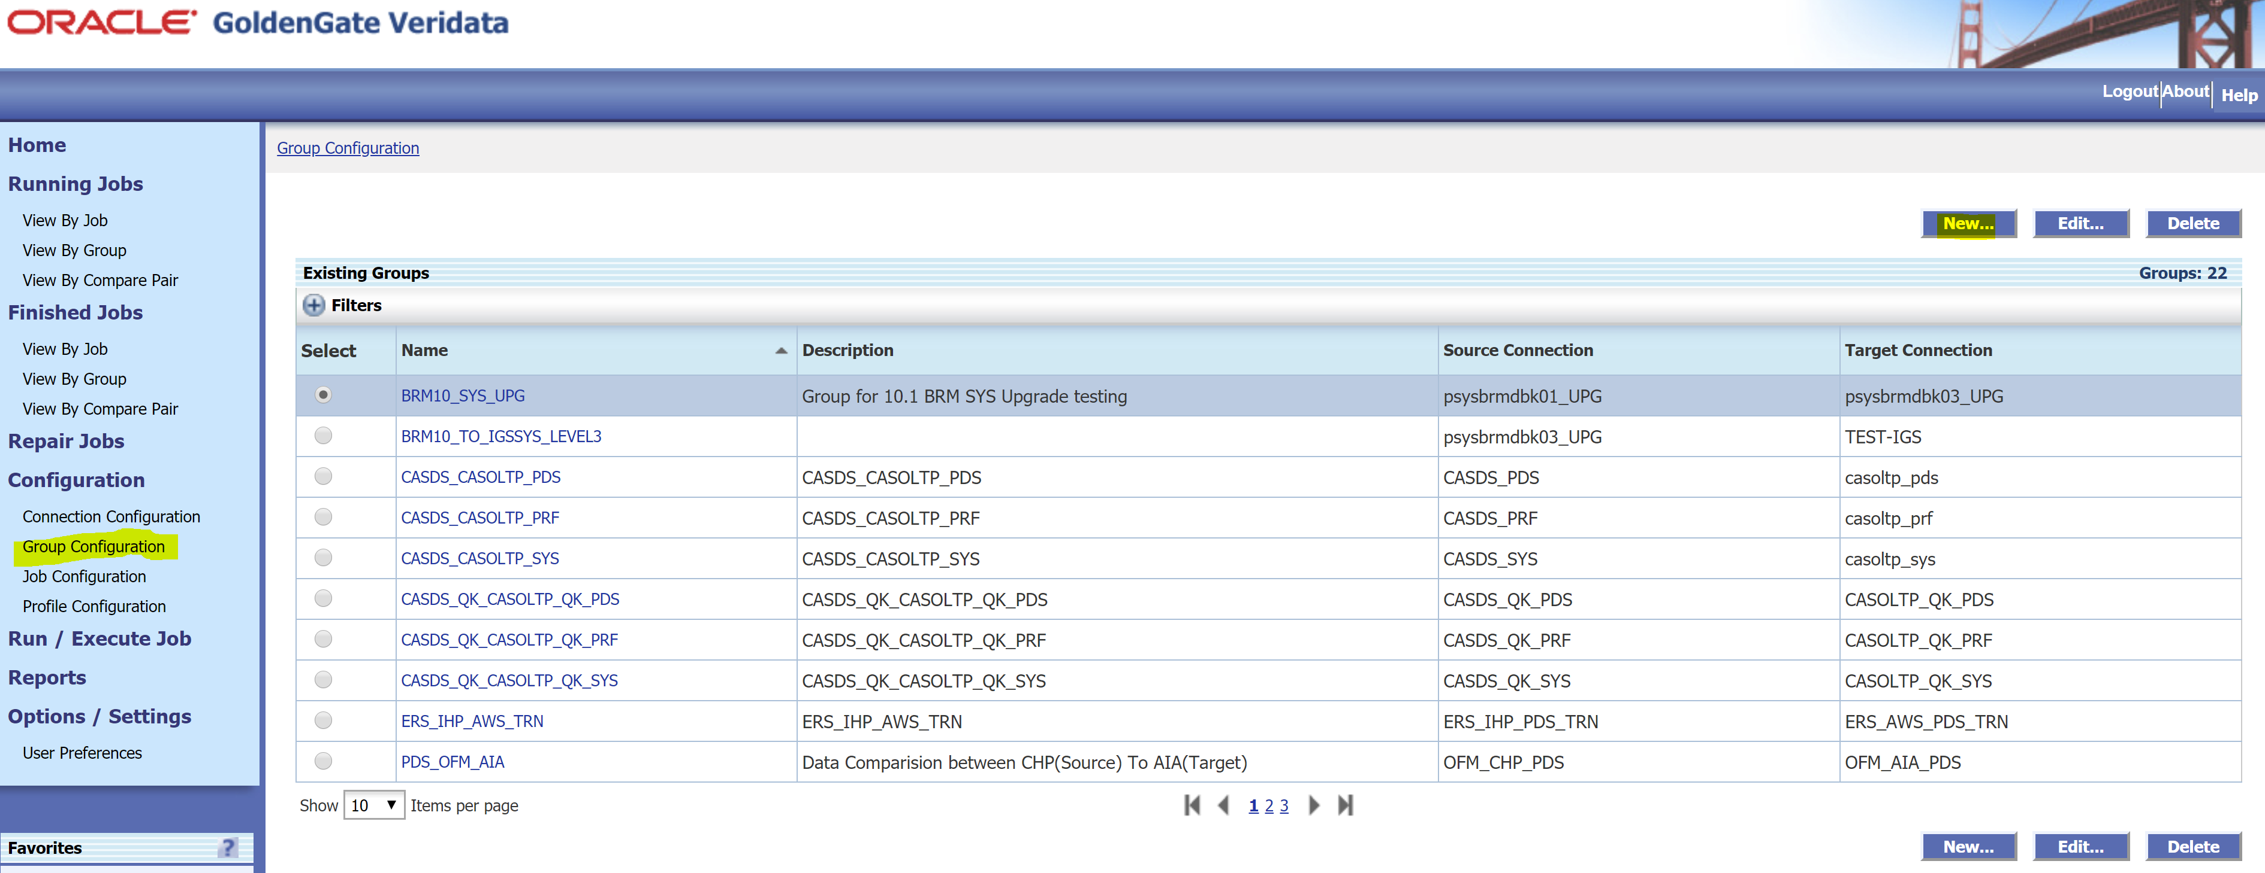

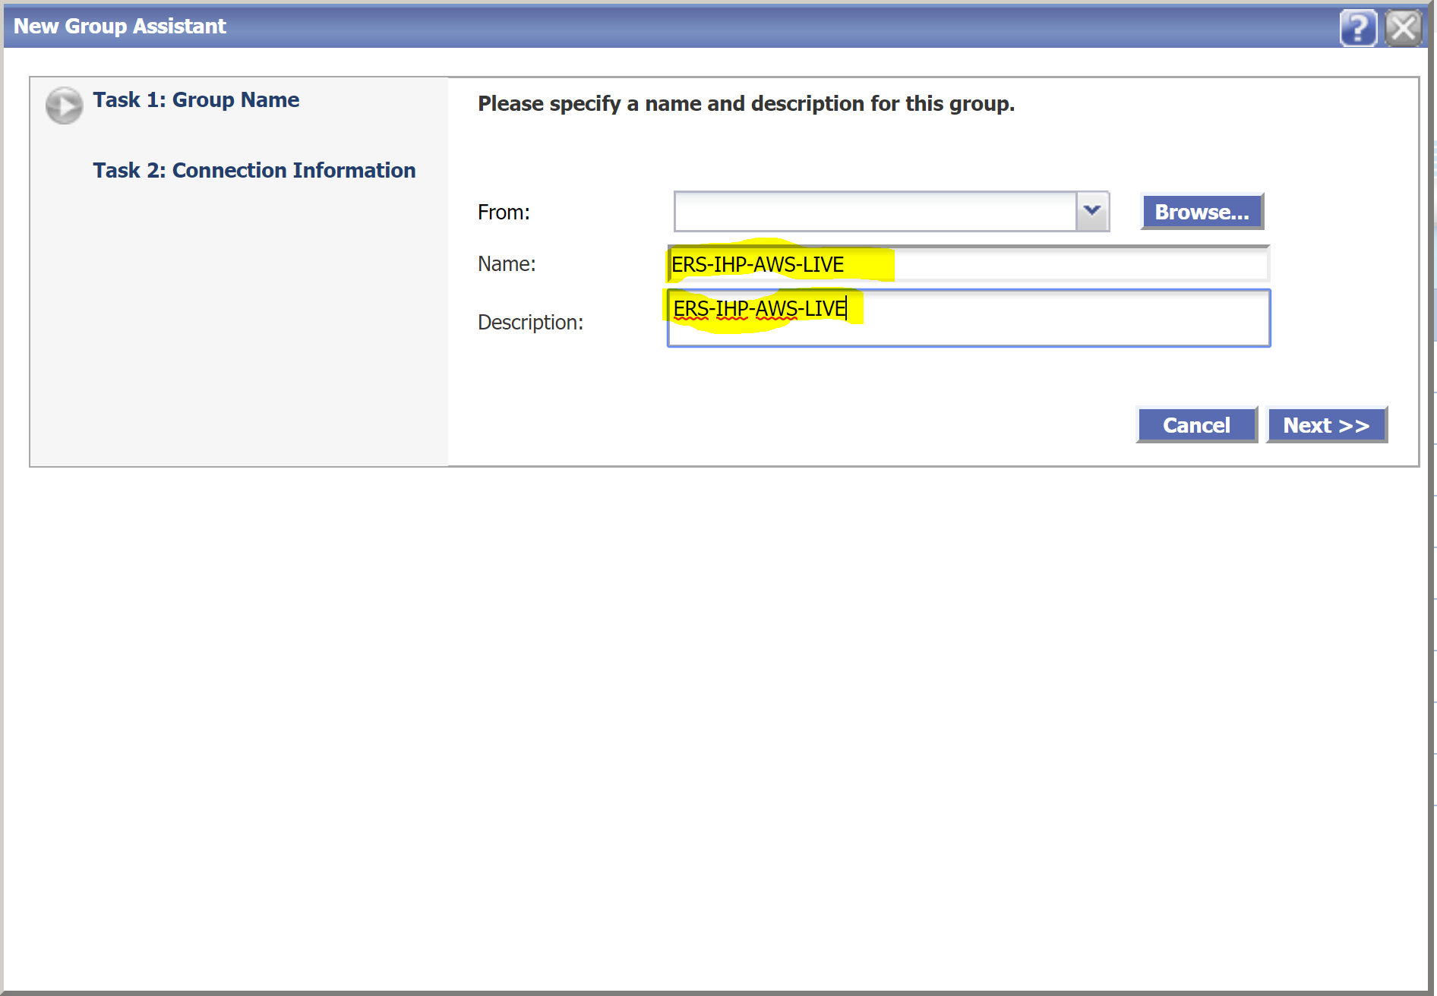

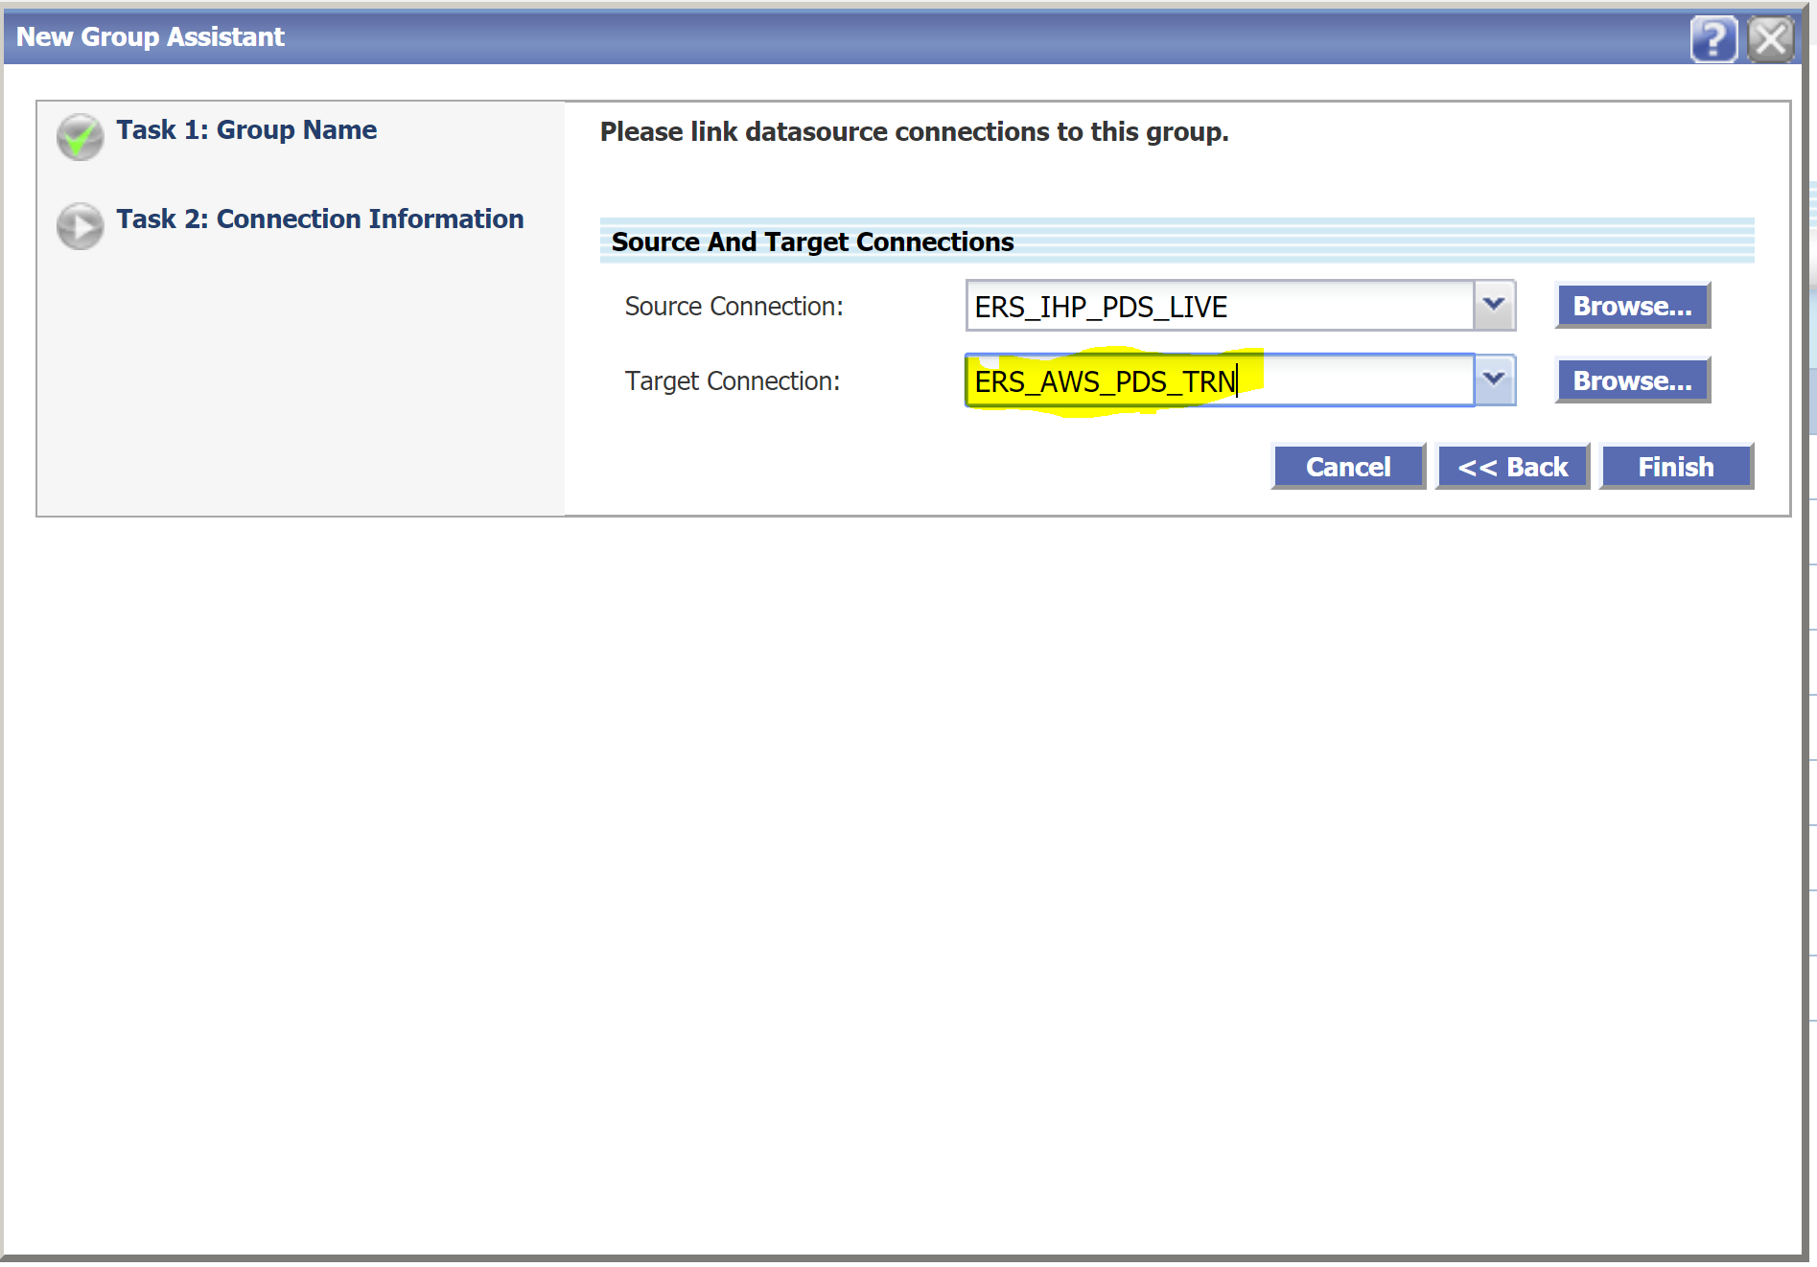

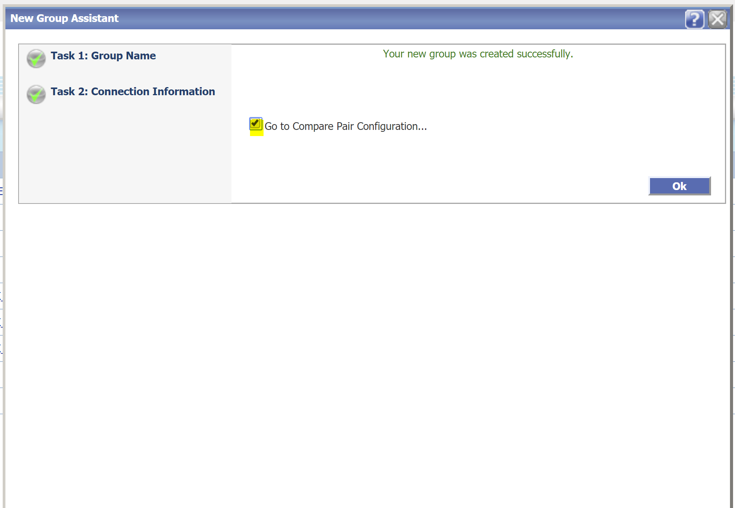

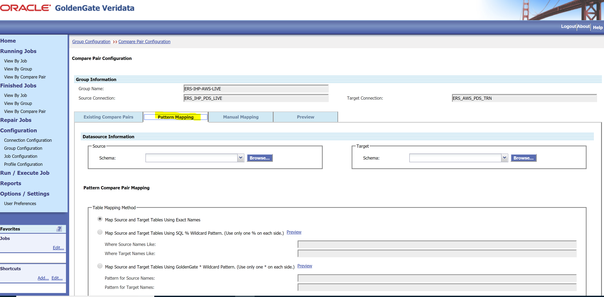

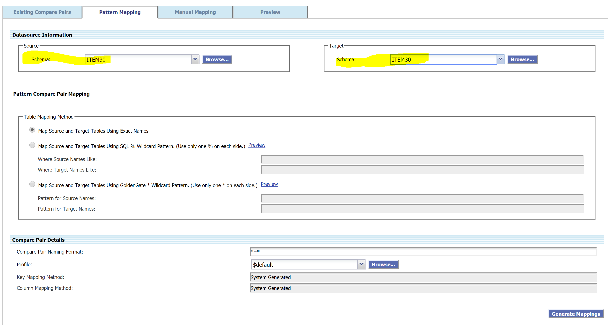

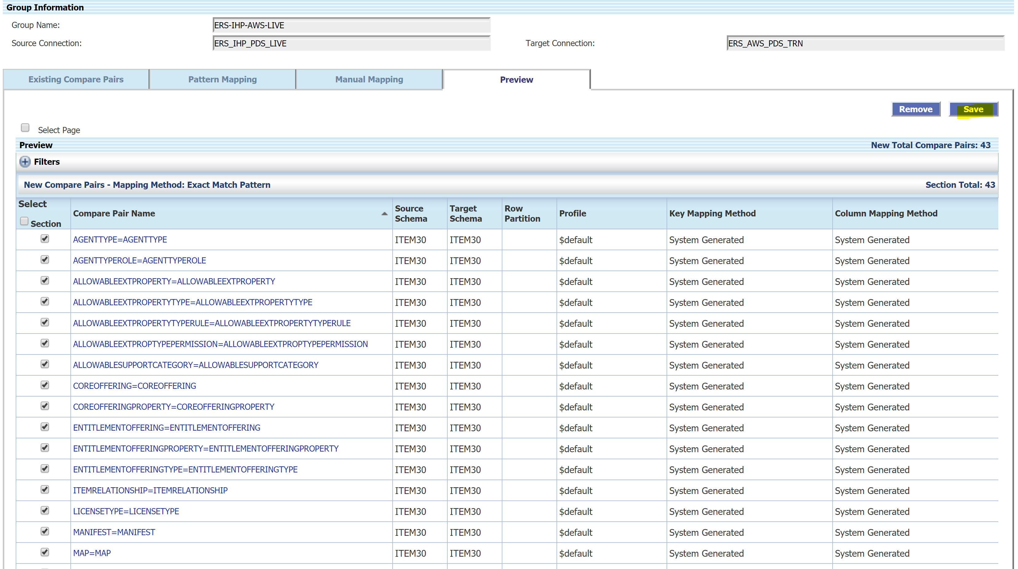

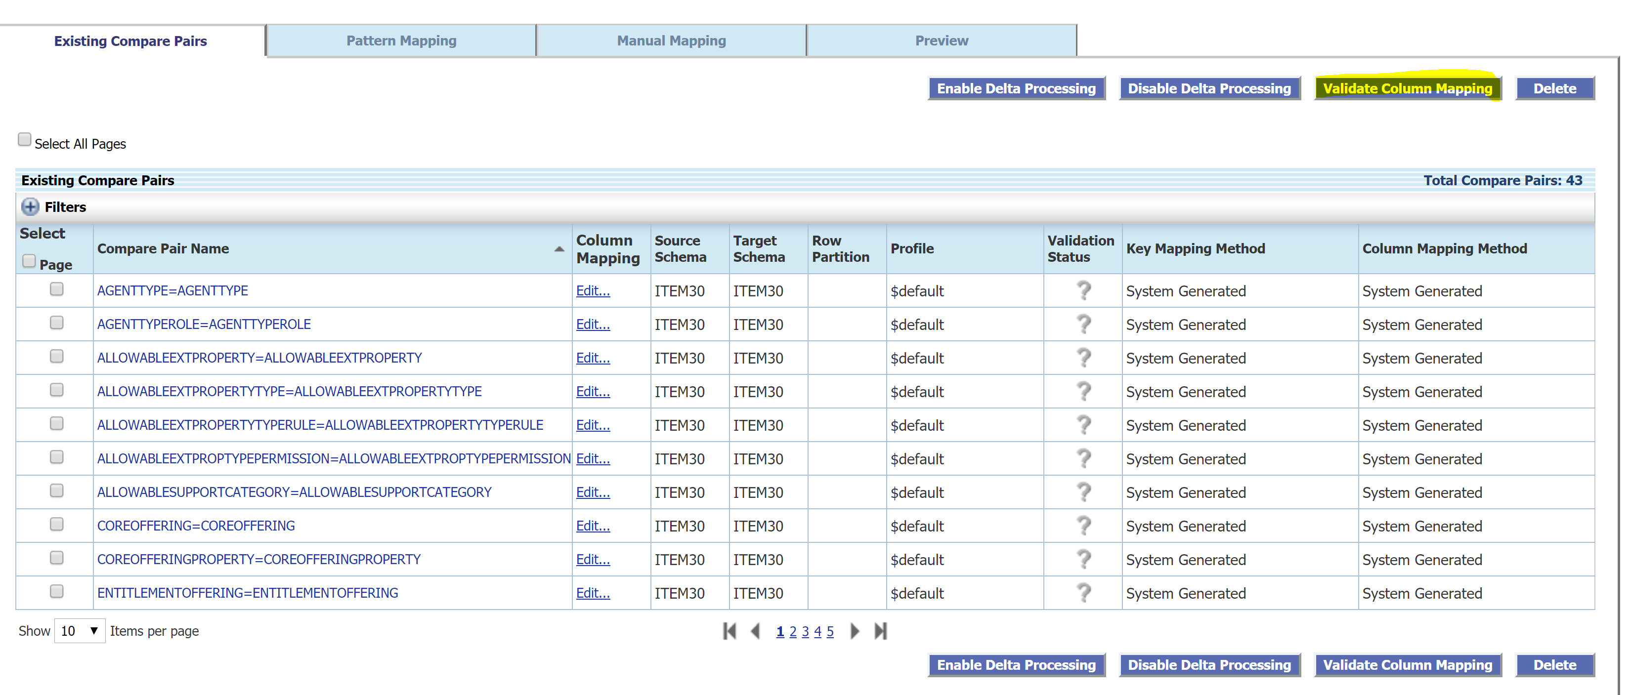

**System generated.**

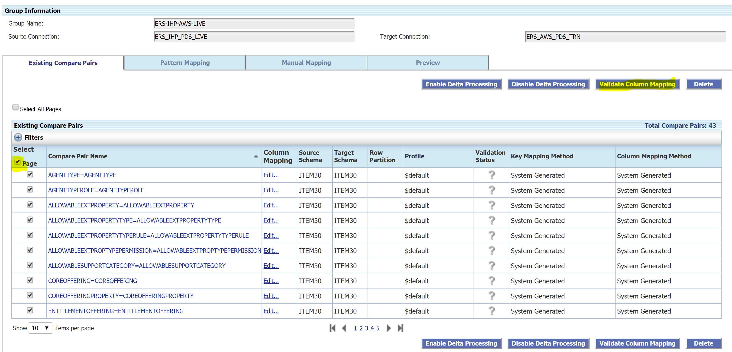

**Manual Mapping:**

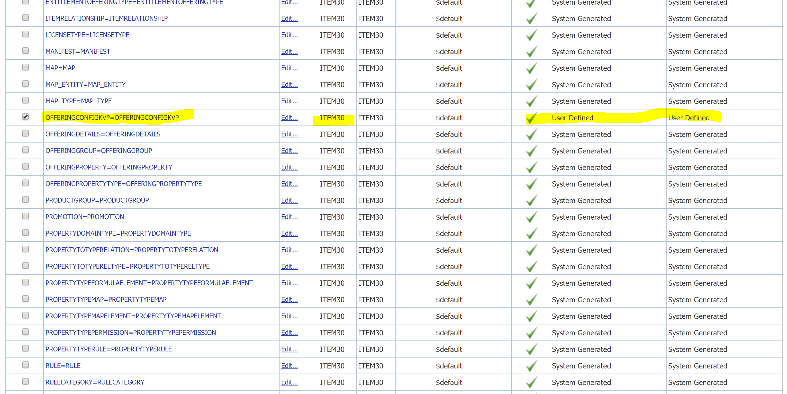

**Job configuration:**

